This is the workflow of the project
Developer pushes to dev
↓
Dev CI pipeline runs
↓
Create PR: dev → main
↓
Code review
↓
Merge into main
↓
Main CD pipeline runs
↓
Build → Scan → Push Docker image

Step 1: Clone the repository of github and enter inside the repo directory
git clone <git repo>

cd <git repo directory>

run git init command to initialize the current directory into git repo
git init

Create a dev branch
git checkout -b dev

now in dev branch all the code from the main branch will get copied, and work on
code locally to check it is running perfectly fine ( docker expose)
push all the changes into the dev branch ( not to the main branch) ( do not create github action yaml otherwise it will trigger the flow)

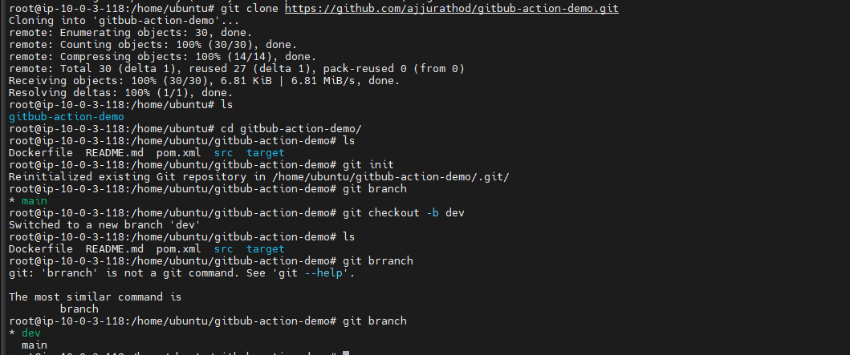
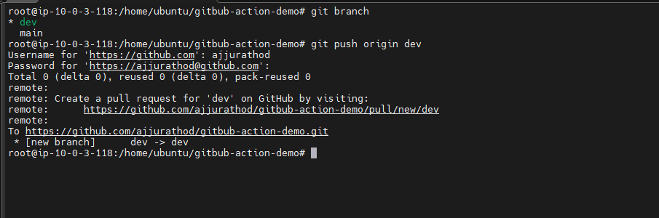

Step 2: Now create a github-runner ( this is where out github pipeline will run)
Come out of directory of github repository and be root directory /home/ubuntu
To create a github runner we have to be out of sudo
To create user without sudo
adduser <user-name>

this will create user and now switch into that user
su - <user-name >

be in githubuser
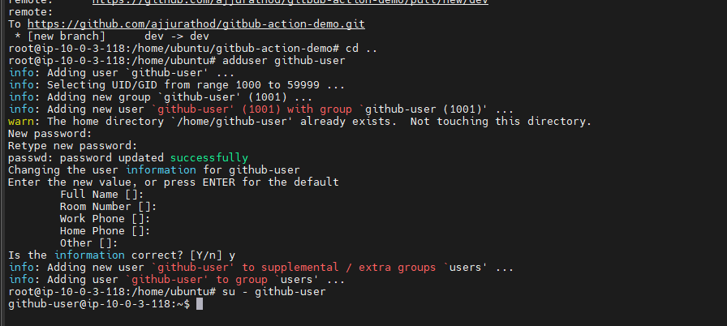

Open github repo
setting of repoactionsrunnerlinux and run the given command inside github-user and label runner and self-hosted

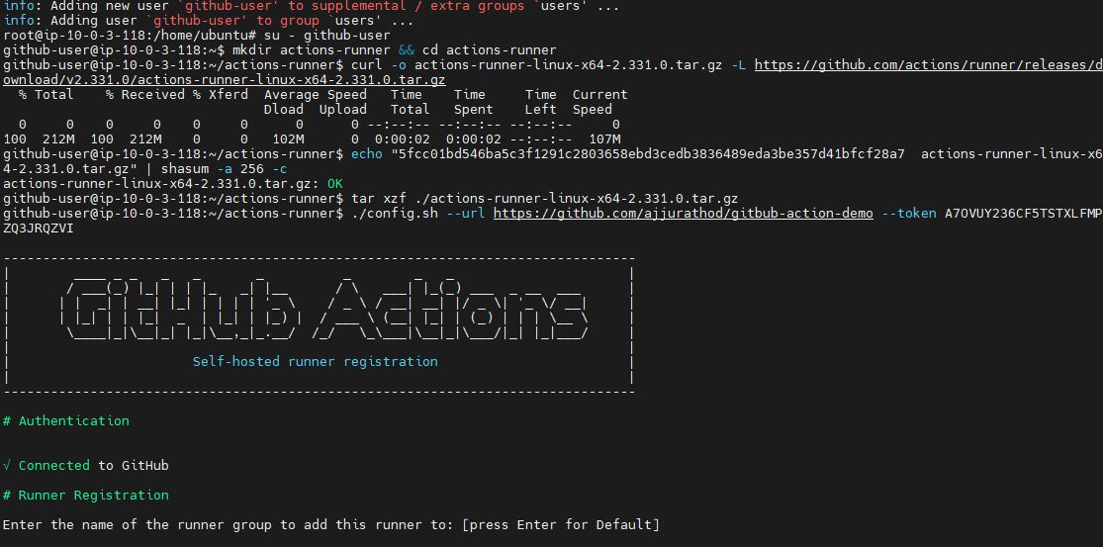
On hear our github action pipeline will run
And now come out of the github-user by running exit command
exit

be in /home/ubuntu and install the following tools
Before running the pipeline install maven, trivy, docker and java ( if maven installed then no need to install java) on ec2
Or else you will get an error saying command not found

And enter inside the git repo directory
Be in dev branch
Create a github-action yaml file for dev branch
vi .github/workflows/dev-ci.yml

Cicd pipeline for dev to test whether the application is working or not

name: cicd -pipeline-dev

on:
push:
branches: ["dev"]

jobs:
maven-build:
name: maven-build
runs-on: self-hosted

steps:
- name: code checkout
uses: actions/checkout@v4

- name: Setup Java
uses: actions/setup-java@v4
with:
distribution: temurin
java-version: 17

- name: mvn build
run: mvn clean package

- name: Upload JAR artifact
uses: actions/upload-artifact@v4
with:
name: app-jar
path: target/demo-app-1.0.jar

docker-build:
name: build docker
runs-on: self-hosted
needs: maven-build

steps:
- name: code checkout
uses: actions/checkout@v4

- name: Download jar artifact
uses: actions/download-artifact@v4
with:
name: app-jar
path: target

- name: Docker build image
run: docker build -t ${{ secrets.DOCKER_USERNAME }}/github-demo:dev .
trivy-scan:
name: trivy scan
runs-on: self-hosted
needs: docker-build

steps:
- name: scan image
run: trivy image ${{ secrets.DOCKER_USERNAME }}/github-demo:dev

docker-expose:
name: docker expose
runs-on: self-hosted
needs: trivy-scan

steps:
- name: docker expose
run: docker run --name github-cont -td -p 8080:8080 ${{ secrets.DOCKER_USERNAME }}/github-demo:dev

and push changes to dev branch
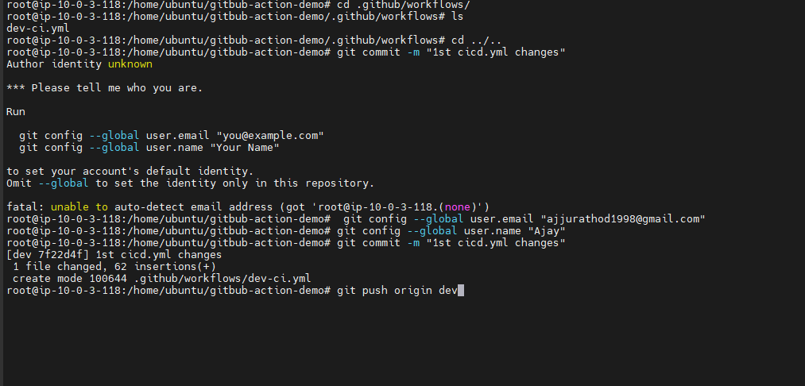

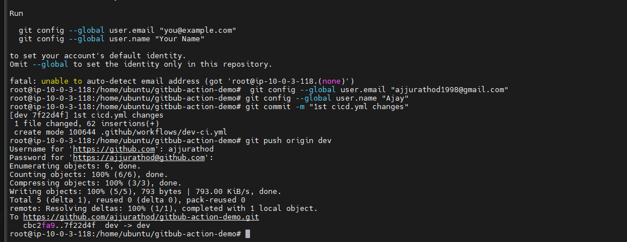

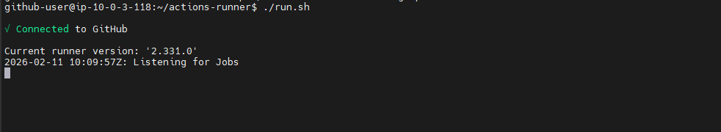

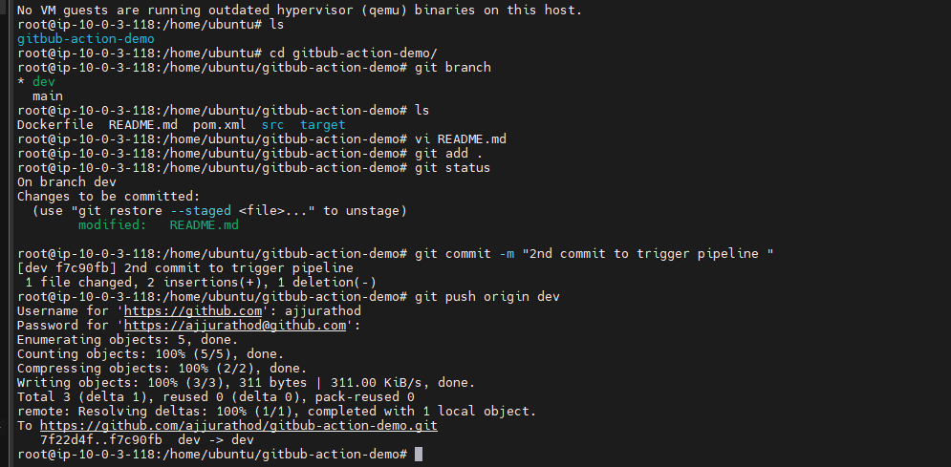

Once you push the code to the dev branch gihutb action will automatically trigger

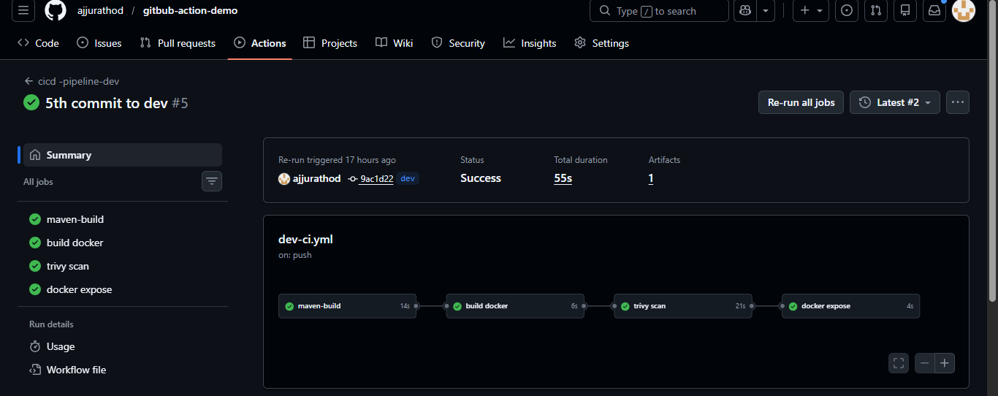

Once it is running fine then create a pull request from dev to main branch
Serior will review the code the accept the code that it

GitHub action code for the main branch
This pipeline will trigger under two conditions
- On push
- On pull_request from any branch to the main branch

name: cicd -pipeline-main

on:
pull_request:
branches: ["main"]
push:
branches: ["main"]

jobs:
maven-build:
name: maven-build
runs-on: self-hosted

steps:
- name: code checkout
uses: actions/checkout@v4

- name: Setup Java
uses: actions/setup-java@v4
with:
distribution: temurin
java-version: 17

- name: mvn build
run: mvn clean package

- name: Upload JAR artifact
uses: actions/upload-artifact@v4
with:
name: app-jar
path: target/demo-app-1.0.jar

docker-build:
name: build docker
runs-on: self-hosted
needs: maven-build

steps:
- name: code checkout
uses: actions/checkout@v4

- name: Download jar artifact
uses: actions/download-artifact@v4
with:
name: app-jar
path: target

- name: Docker build image
run: docker build -t ${{ secrets.DOCKER_USERNAME }}/github-demo:dev .
trivy-scan:
name: trivy scan
runs-on: self-hosted
needs: docker-build

steps:
- name: scan image
run: trivy image ${{ secrets.DOCKER_USERNAME }}/github-demo:dev

docker-push:
name: docker push
runs-on: self-hosted
needs: trivy-scan

steps:
- name: docker login
run: echo "${{ secrets.DOCKER_PASSWORD }}" | docker login -u "${{ secrets.DOCKER_USERNAME }}" --password-stdin

- name: docker push
run: docker push ${{ secrets.DOCKER_USERNAME }}/github-demo:dev

